

FAMILY FUN
AT FAMILY NIGHT AT THE YMCA
Meet your friends and family at the YMCA for a host of fun and free activities for all ages:

6:00-6:45 Tumble & Climb in the Gym (best for ages 2-7) under the supervision of Y staff
7:00-7:45 Enjoy a Magic Show with David Levitton
Sponsored by the Tarrytown Recreation Dept.
8:00-8:45 Family Swim! Bring your suits and towels and jump in for a refreshing evening splash!
5:30-8:30 Do a Family Art Project with the Tarrytown & Sleepy Hollow Arts Council. All ages welcome.

Please note that a parent or guardian must accompany all children under the age of 14. Thank you!

FAMILY DINING SPECIALS
- Bellas: Come early before you go the Y and take $2 off ANY children’s meal PLUS get a FREE donut for dessert. Special runs from 4:30-6:30.
- Jack & Dyl’s: $5.00 for any children's meal all evening

- Mi Bohio: Five can dine upon tonight's Latin Special, Jalea, a fried seafood platter served Family Style - $28.00 – served with special sauce and fried casaba.

- Main Street Sweets: Try the What-A-Lot-A-Sundae 12 Scoops, 6 Toppings, Whipped Cream & Cherry in ONE big Family size bowl. Yummy & Fun! $2 off. Tonight Only.

FAMILY HISTORIES
- THE HISTORICAL SOCIETY OF THE TARRYTOWNS presents “Prominent Historic Families of Tarrytown & Sleepy Hollow”, a presentation featuring well-known (and not so well-known) area families, including those deep dark secrets that made them infamous! Join curator Sarah Mascia and numerous Board Members at the Historical Society on Grove & Neperan from 5-8. Refreshments will be served. Please call 631-8374 for additional information.

ART SCENE
- Heritage Frame: OPEN HOUSE-GRAND OPENING! Come visit Ted and his staff at their new location at 8b Main Street, right across from the Music Hall. Enjoy some wine and cheese and check out the new space!

- Gallery du Soleil: New Paintings by Colette Laruelle, "Connecting with Nature". For additional information call 332-4554 or go to www.gallerydusoleil.com. Gallery hours: Tues to Sat, 11- 6 & Sun 11-5

- Coffee Labs Roasters: Art Opening for local pet portrait artist Gerri Green featuring poodles, labs, calicos, collies and more…come check out the sweet faces on these canine and kitty creations, meet the artist, and commission your own! 5-8

- Rivertown Painter Studio: Ronnie Levine invites you to an Open Studio tour tonight at One Neperan Rd. 2nd fl. Please call if planning to stop by at 332-5050. PLEASE CALL TO SCHEDULE. 5-8

MERCHANT SPECIALS
Enjoy the charm of shopping Downtown Tarrytown!

- Baby Bee’s: Have you recently added a “New” member to the Family? Stop in and receive a free gift tonight, for your new baby (0-12m). Too cold to come out and need a gift? Call us, we deliver! Local Gift Delivery and Shipping Services available.

- Barbara Sternau Interiors & The Design Shop: Please come by and browse at this lovely shop featuring elegant furnishings, candles, soaps, books and much more. Interior design & upholstery services as well! 5-9

- Flying Fingers Yarn Shop: When you purchase yarn, supplies or books for yourself tonight, your child will receive complimentary yarn and a basic knitting lesson. 5-9

- The New Age Shop: Enjoy 10% off all new age books tonight, PLUS, purchase 12 incense sticks for $1. Please ask about our Tarot Readings!

- Pretty Funny: We have wonderful vintage items in the shop for all of the people in your family. Stop by tonight and take 10% off your entire purchase.

- River Photo Studio: Book your family portrait session by the end of February and receive an $80 dollar credit towards your photo purchase. Located right above the Music Hall marquee! 5-9

- Russell & Lawrie Pharmacy: 25% OFF ALL Vitamins tonight and through the end of February when you mention Third Friday. Under new ownership! Don’t forget to ask about store specials.

- Salon 2000: Valentine’s Special for Month of February: Purchase one tanning session at full price and get the second of equal or lesser value for FREE. Please call 631-2000 to make an appointment.

- Star jewelry: Come see the expanded store. Mention Third Friday and receive a FREE pair of earrings. Sale. Sale. Sale.

- Tarrytown Cycle: Tarrytown Cycle has a great selection of men’s, woman’s and children’s bikes as well as trailers, accessories and clothing for biking.

- Tarrytown Woodworks-Open House: Learn about fine furniture care, traditional woodworking techniques and antique restoration with owner Eric Clingen. 5-7

- Timeless Seasons: Enjoy special discounts of $5-$35 off selected items (not including sale items).

- Whimsies: Take 10% off your entire purchase tonight.

OTHER ATTRACTIONS
- Family Night: The Reformed Church of the Tarrytowns invites you to join them for children’s music at 6:00, FREE Spaghetti Dinner at 6:30, and an animated Bible Story film at 7:30. Call 631-4497 for info. ALL WELCOME!

February 16, 2007
5pm-9pm
Main Street & Broadway

Celebrate Family

Third Friday is brought to you by the Merchants
of Tarrytown & The Village of Tarrytown with the support of The Tarrytown Recreation Department, The Tarrytown & Sleepy Hollow Chamber of Commerce, and The Tarrytown & Sleepy Hollow Arts Council, with a special thanks to Allan Block Insurance, The Family YMCA at Tarrytown, Heritage Frame & Wachovia Bank.

www.sleepyhollowchamber.com
Call 914-862-1828 or 914-631-1705 for information.
Take advantage of our New VALET PARKING SERVICE at the Main Street Municiple lot.

Book Drop:
Please bring new and
gently used children's
and youth books to
the YMCA. All collected
books will be donated to the
children of the Even Start families.
Thank you!

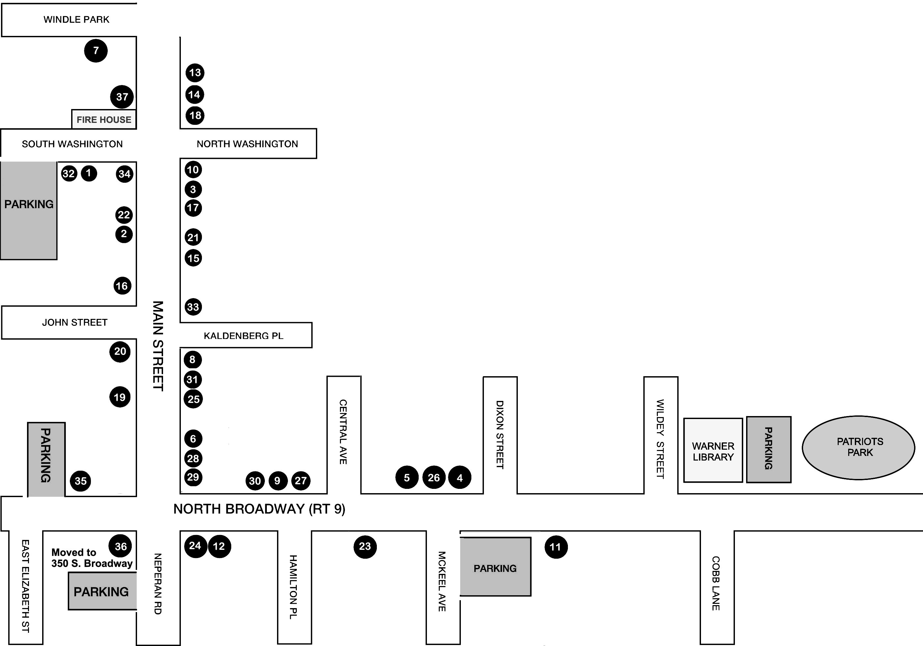

CULINARY SPECIALS
Enjoy an evening of discounts, complimentary tastings, and special menu additions.
• Anna Shea Chocolates: $1 off a 6-piece box of assorted handmade chocolates. Come earlier this week for out-of-the ordinary Valentine’s Day gifts for the ones you love!
• Caravela: $10 off Dinner for two & $20 off Dinner for four.
• Isabella’s: Enjoy 10% off bills totaling $25 or more, and 15% off $100 or more.
• Jack & Dyl’s: Special under Family fun section.
• Lago Di Como: Tonight, guests can enjoy a special price of $7.95 on select pastas on the menu all evening long.
• Mi Bohio: UNDER NEW OWNERSHIP – Come check it out! Latin Fine Food. Special listed under Family fun section.
• Main Street Café: Ask about their Third Friday Specials!
• Taste of China: Free Wonton Soup with purchase of $10
• Tony's Pizzeria: Take $1 off any pizza ordered tonight!
• Mint: Kids will get a FREE container of natural peanut butter tonight – they can even make it themselves!!
• Grape Expectations: Bring this flyer to the shop anytime and receive 15% off any wine purchase. 6-8
• At Santa Fe: Club members can take advantage of Double Points every Third Friday!
• Main Street Sweets: Please find special under Family fun section.

MUSIC AND DANCE
- Singer/songwriter Mike Hollis will be playing at Coffee Labs this evening. 8-10

- After Hours and Unplugged at Jack & Dyl’s with owner David and his acoustic-slinging guitar buddies. Have a drink and tap your foot to some non-traditional tunage! 9:30-11:30

- Do you watch "Dancing With The Stars" on ABC? Would you like to try it? Swing by Fred Astaire Dance Studio tonight for a studio tour and to schedule your FREE TRIAL PRIVATE LESSON. No partner needed. New customers only. 5-9

Thank You!
Thank you for joining us for Tarrytown Third Friday. Please spread the word that every month, rain or shine, Tarrytown invites everyone to make a night of it. For future monthly schedules log on to www.sleepyhollowchamber.com
Send emails to: tarrytownthirdfriday@gmail.com

The next Third Friday is

March 16th / Celebrate Literature

Including an Author Fair at Warner Library as well as a special showing of “Word-Play”, poetry readings, a LIVE tattoo demonstration (poetry of course), and a Literary Scavenger Hunt.
ASK PARTICIPATING 3rd FRIDAY SHOPS & RESTAURANTS IF THEY HAVE ANY SPECIALS TONIGHT:
ADDITIONAL PARKING OFF THE MAP… Washington Irving Middle School (Franklin Street Lot) & The Train Station Parking Lot at the bottom of Main Street. ALSO, patrons may now take advantage of VALET PARKING in Tarrytown on Friday and Saturday nights – follow the signs!

1. Anna Shea Chocolates / Gourmet Chocolates
2. Baby Bee’s Boutique / Children’s Specialty
3. Barbara Sternau Designs / Interior Design
4. Baskin Robbins / Ice Cream, Cakes & Shakes
5. Caravela / Portuguese & Brazilian Cuisine
6. Coffee Labs Roasters / Coffee & Treats
7. Family YMCA at Tarrytown
8. Flying Fingers / Specialty Yarn Shop
9. Fred Astaire Dance Studio / Dance Instruction
10. Gallery du Soleil / Contemporary Art
11. Grape Expectations / Wine and Classes
12. Heritage Frame / Framing & Framed Art
13. Isabella’s Restaurant / Brick Oven Pizza
14. Jack & Dyl’s / American Bistro
15. Lago di Como / Italian Cuisine
16. Main Street Cafe / American Cuisine
17. Main Street Sweets / Homemade Ice Cream
18. Main Street Pizza / Italian Food
19. Mi Bohio Café / Closed for Renovations

20. Mint Premium Foods / International Gourmet Foods
21. New Age Shop / Gifts, Tarot Readings
22. Pretty Funny / Antiques & Collectables
23. The Reformed Church of the Tarrytowns
24. Rivertown Painter’s Studio/ Ronnie Levine
25. River Photo Studio/ Portrait Studio
26. Russell Lawrie Pharmacy
27. Salon 2000/ Hair Salon & Tanning
28. Santa Fe / Mexican Food
29. Star Jewelry / New & Estate Jewelry
30. Tarrytown Cycle / Bikes, Boards & More
31. Tarrytown Music Hall / Live performances, Movies, Dance
32. Tarrytown Woodworking / Restoration
33. Taste of China / Chinese Food
34. Timeless Seasons / Clothing, Bags & Jewelry
35. Tony’s Pizzeria / Pizza & Italian Food
36. Wachovia Bank
37. Whimsies / Eclectic Gifts

